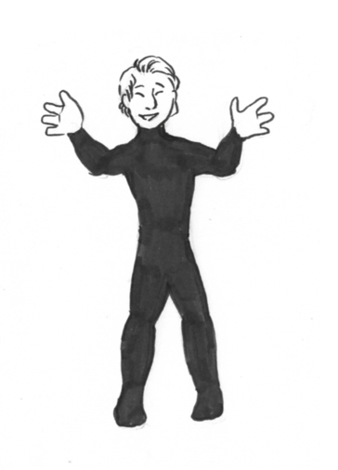
Hidden Grammars & How to Teach Them
Alice Savage & Colin Ward, Lone Star College – North Harris
Houston, Texas, USA
BLOG: www.EnglishEndeavors.org

LEXICAL GRAMMAR & READING

A. Identify Thought Groups
Listen to the sentence. Mark the thought groups you hear.

Most of the stories tell of dolphins that saved people from drowning in the ocean.
B. Practice Thought Groups
Listen to your partner read the sentence. Mark the thought groups that you hear.
Sailors painted dolphins on their ships, and ancient Greek coins showed a dolphin with a boy riding on its back.

DISCOURSE GRAMMAR & READING

A. Notice Paragraphing
Read the text. Mark where the writer should start a new paragraph.

Stories of dolphins saving humans have existed since ancient times. Most of the stories tell of dolphins that saved people from drowning in the ocean. Sailors painted dolphins on their ships, and ancient Greek coins showed a dolphin with a boy riding on its back. Do these images and stories have any truth to them? Todd Endris thinks so. Endris was sitting on his surfboard off a beach in California waiting for a good wave to ride. Suddenly, a great white shark attacked him. Endris held onto the board, but the shark attacked him a second time. The shark took hold of Endris’s leg and tried to pull him into the water. Just then, a group of dolphins arrived. They swam in circles between Endris and the shark. Endris was able to get back on his surfboard and reach the shore. An ambulance rushed him to the hospital. He lost a lot of blood from the attack and almost died. Endris believes the dolphins saved his life. In New Zealand, four lifeguards were in the ocean when a great white shark came near them. It started to swim around them. The lifeguards thought the shark was going to attack. All of a sudden, a group of dolphins arrived. The dolphins swam between the lifeguards and the shark, and the lifeguards were able to escape. In the Gulf of Aqaba, a British tourist was swimming. A group of sharks moved in and started to attack him. Three dolphins appeared. They jumped in and out of the water and hit the water with their tails. The sharks swam away. Once again, dolphins saved a human’s life. Humans aren’t the only ones dolphins rescue. In New Zealand, two whales swam into shallow water. People tried to lead the whales back to deep water, but the whales kept swimming the wrong way. A dolphin appeared and swam between the rescuers and the whales. The whales immediately followed the dolphin as it led them to deep water.

THE GRAMMAR OF CONVERSATION

Read the dialog. Answer the questions. Then practice and perform. Don’t forget feelings!
C: I don’t know how you do it.  D: Do what?  C: Everything?  D: I have no idea what you are talking about.  C: You have a full-time job, a business on the side, you take care of your kids, and your house is always clean! Well, I’m sorry, but that’s impossible.  D: I know. I don’t know how I do it either! | - Who is talking and where are they?  - What do they want to achieve and are they successful?  - What formulaic language fits the situation?
E: So this is the best fesenjun/mole/curry/ I’ve ever eaten.  F: Oh, you’re just being nice.  E: No, I’m serious. It’s magnificent. Can you teach me how to make it?  F: I don’t know. I never write anything down. I just sort of do it.  E: It’s so good! I want to make it for my friends next week. Maybe I could watch you.  F: No,. . . I’ll just come and make it for you. | - Who is talking and where are they?  - What do they want to achieve and are they successful?  - What formulaic language fits the situation?
3.  G. You were great tonight! I was completely blown away.  H: Thank you. I’m so glad you liked the show.  G: You ought to be in the movies.  H: Aww, that’s very sweet of you. It wasn’t me though. It was the director. She’s amazing, and the writer of course.  G: Oh, you’re just being modest.  H: It’s true. This show is a team effort! | - Who is talking and where are they?  - What do they want to achieve and are they successful?  - What formulaic language fits the situation?
4.  K. Not a bad shot . . . for an old man.  L: Look who’s talking!  K: Hey at least I can still see the basket.  L: Sure, as long as you have a telescope.  K: I don’t need one. I can just borrow yours.  L: I’ll trade it for your wheelchair.  K: You wish! | - Who is talking and where are they?  - What do they want to achieve and are they successful?  - What formulaic language fits the situation?

